Group 3 - Nathan Ketterlinus, Preet Chodavadia, Legendre Cooper, Owen Segala, Kevin Yomba

COSC350-001

Yeong-Tae Song

10/27/24

Description of the Socket Implementation

Socket Type: TCP socket from the java.net.Socket library. Functionality defined here: <https://docs.oracle.com/javase/8/docs/api/java/net/Socket.html>

How it works:

User Manual

Before You Start:

Ensure that your device and firewall are configured properly to allow for inbound and outbound traffic. The program uses port 31847 by default. The TCPServer_Enhanced.java GUI will list a server IP address defined by clientSocket.getInetAddress(). Depending on your device configuration this could be one of several IPs your device can use, and will likely be an internal IP address. On the client, inputting any pingable IP address belonging to the server should allow for communication, even if it is not necessarily the one shown in the server GUI.

Getting Started:

1. Compile and run TCPServer_Enhanced.java on the machine you would like to be the server. A GUI should pop up listing the server’s IP address (you will need this later), as well as a “Waiting for client” message, as pictured below.
2. Compile and run TCPClient_Enhanced.java on the machine you would like to be the client. A GUI should pop up with an editable text box for the target server’s IP at the top, as pictured below. By default, this value will be 127.0.0.1, and is the default loopback address which allows the two programs to communicate when running on the same device. The port display box should say 31847, and should be left alone unless changing the java files directly to use different ports.

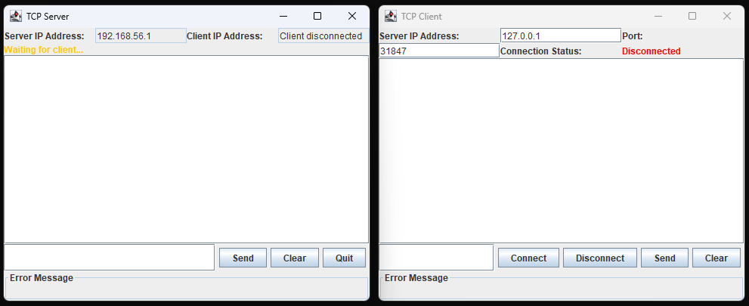

1. Once the server IP is typed in the Client program, pressing Connect attempts to establish a connection with the entered address and port, and if successful should change the Connection Status to “Connected” on both client and server. Now the software is ready to send and receive messages!

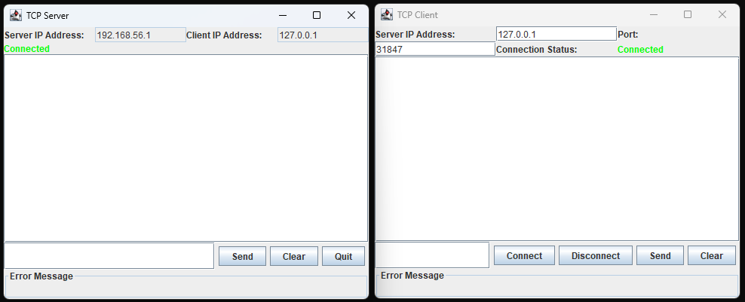

1. On both the server and client, messages can be entered in the test box in the bottom left, and can be sent with the Send button. The chat box can similarly be cleared with the Clear button, and the server can shut down with the Quit button, while the client can disconnect from the host with Disconnect

